***Dt : 3/9/2022***

***\*imp***

***Creating Java Project Uisng IDE Eclipse:***

***(IDE - Integrated Development Environment)***

***step-1 : Open IDE Eclipse,while opening name the WorkSpace(folder)***

***and click 'Launch'***

***step-2 : Create JavaProject***

***Click on File->new->Project->Java->select 'Java project' and click***

***'next'->name the project and click 'finish'***

***step-3 : Create packages in 'src'***

***Right click on 'src'->new->package,name the package and click***

***'finish'***

***step-4 : Create classes in package***

***RightClick on package->new->Class,name the class and click 'finish'***

***Note:***

***=>To increate font,click on Window->Preferences->General->***

***Appearance->Colors and Fonts->Java->Java Editor Text Font->...***

***CalculateSalary.java(SubClass)***

***package p1;***

***public class CalculateSalary {***

***public float calculate(int bSal)***

***{***

***return bSal+(0.93F*bSal)+(0.63F*bSal);***

***}***

***}***

***EmpMainClass.java(MainClass)***

***package p2;***

***import java.util.Scanner;***

***import p1.CalculateSalary;***

***public class EmpMainClass {***

***public static void main(String[] args) {***

***Scanner s = new Scanner(System.in);***

***System.out.println("Enter the bSal:");***

***int bSal = s.nextInt();***

***if(bSal>=12000)***

***{***

***CalculateSalary cs = new CalculateSalary();***

***float totSal = cs.calculate(bSal);***

***System.out.println("TotSal:"+totSal);***

***}***

***else***

***{***

***System.out.println("Invalid bSal...");***

***}***

***s.close();***

***}***

***}***

***step-5 : Execute the program***

***Open MainClass and click Run->Run***

***===============================================================***

***Diagram:***

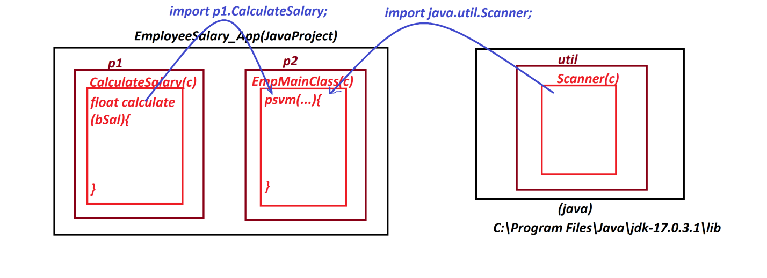

***============================================================***

***Assignment-1:***

***JavaProject : StudentResult***

***packages,***

***p1 : CheckBranch,TotalMarks,Percentage***

***p2 : StudentMainClass***

***Assignment-2 :***

***JavaProject : ArithmeticOperations***

***packages,***

***p1 : Addition,Subtraction,Multiplication,Division,***

***ModDivision***

***p2 : ArithmeticMainClass***

***==============================================================***